JOUR 4251 7.2 Persuasion and attitude change
Midterm evaluation recap
● Overall, you seem pretty happy with this class
● Very helpful / insightful
● Sometimes helped me realize that not all opportunities are clear ● I will try to implement as much as possible
● I will explain why I cannot /will not implement all
○ Out of my control
○ Learning purpose
○ Divided opinions in class
■ More group work - less group work
■ Continue reading responses - reading responses are busy work ■ Being strict on phones - be stricter on phones
■ Call on people yes or no
Midterm evaluation recap
● Recaps at the beginning of class ● Menti quizzes + practice quiz ● Videos / examples
Continue
● Slides (design, number of words, availability on Canvas, speaker notes) ● Give us reminders in class about deadlines + announcements ● Providing grading rubric in advance
● Review sessions
● Care and reach out to students / your personality, attitude (accent) ● Structure, routine / due dates on same time / being organized ● Application of what we have learned
● Tokens
● Good feedback (some want more)
● Manageable amount of readings
● Match midterm and what we discussed in class (felt fair) ● Being an awesome prof / doing what you are doing
Midterm evaluation recap
● Detailed study guide
● Required attendance + tokens for absence instead of ICA ● Tell us when ICAs will be
● Quicker recaps
Start
● Laptop use
● Slow down
● Bigger font on slides ● Guest speaker
Solution
Post slides in advance You can print + make notes
● Menti quizzes (more) or use Kahoot
● More videos / examples
● More interactive (experiments)
● Subtitles in every video
● More practice questions
● “What’s next?” before menti question (vs. at the end)
Stop
Midterm evaluation recap
● E-book through vital source
● Memory test
● Using so many transition slides
● Such weighted exams
● Filling in charts on exams
● Putting pressure on the class to answer review questions. People participate when it is interesting.
Please contact your TA if you can’t access any resources (e.g., readings) or when you want more feedback on your assignments!
We are here to help!
Recap Tuesday (study guide 2.1)
● Media multitasking
● Why is it difficult to multitask?
○ Capacity interference
○ Structural interference
● How can we help multitaskers?
○ Related versus unrelated multiscreening ● Three forms of relatedness
○ Task relevance
○ Congruency
○ Repetition
Persuasion Exam question
Focus on attitude change
A. Generating or changing an evaluative response, such as that something is more favorable
B. Creating or influencing non-evaluative responses, such as beliefs
Models that explain persuasion effects
Yale reinforcement approach
McGuire’s Model of Persuasion
Cognitive Response Model
Dual Process Theories
Unimodel
Yale Reinforcement Approach 
Hovland - and colleagues at Yale
● You rehearse arguments in the message
● Compare them with what you already know
● You change your attitude, if…
● ...the incentives are greater than those associated with the original position
Lasswell’s model
WHO says WHAT to WHOM with WHAT EFFECT
Hovland adapted and tested this.
Looked at source effects, fear messages, etc.
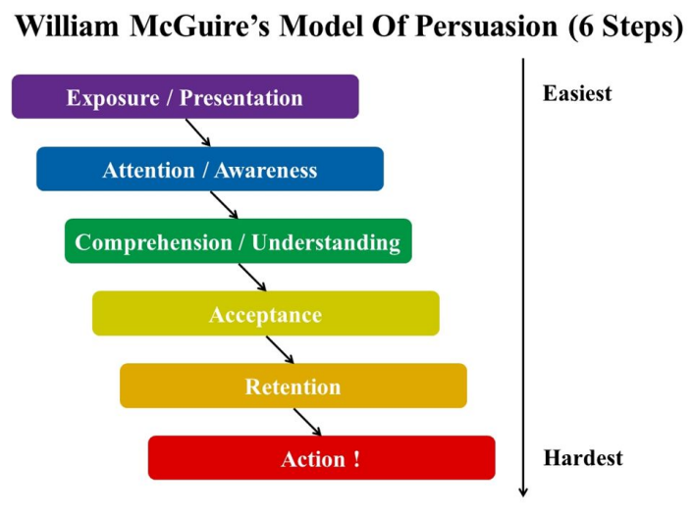
McGuire’s Model 
Assumed messages had to be systematically processed Need to be read and understood and contemplated.
You can have different outcomes at different stages in the model
Probability of influencing attitudes= to the probability of reception (attention/comprehension) + acceptance.
Thus...
Yale Reinforcement approach
You change your attitude, if the incentives are greater than those associated with the original position
McGuire’s Model of Persuasion
Probability of influencing attitudes is equal to the probability of reception (attention/comprehension) and acceptance.
Cognitive Response Model
Individual is ACTIVELY processing information Engaging in a discussion with the message - counterarguing

Thoughts in favor of the argument; Thoughts not in favor of the argument. Not passive.
How to measure? Thought-listing and then categorization
Cognitive Response Model
STRONG arguments
WEAK
arguments
Predominantly favorable thoughts
Predominantly unfavorable
thoughts
CHANGE
No change or negative change
Arguments
Strong arguments
● Full of taste
● Strict quality control ● Well sealable
Weak arguments
● New Formula
● Also in 800g format ● Since 1907

Cognitive Response Model
Persuasion is dependent on:
● Extent to which participants engage in thought related to the message ● The favorability of those thoughts
Distraction can reduce counterarguing and therefore improve effectiveness of the message (e.g., multitasking!)
In sum:
Yale Reinforcement approach
You change your attitude, if the incentives are greater than those associated with the original position
McGuire’s Model of Persuasion
Probability of influencing attitudes is equal to the probability of reception (attention/comprehension) and acceptance.
Cognitive Response Model
Persuasion is dependent on:
● Extent to which participants engage in thought related to the message ● The favorability of those thoughts
What’s next? 
● Reading response Chapter 5
○ Thursday, March 19
○ After spring break, but let’s first enjoy the break!

